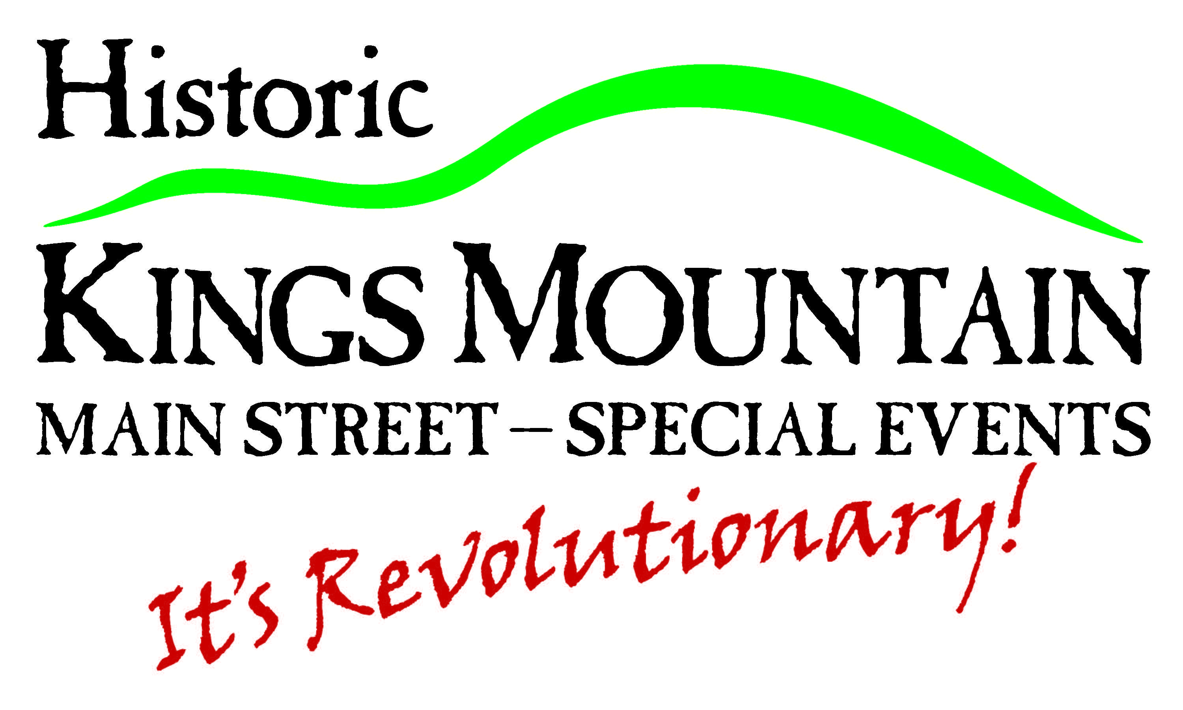

**City of Kings Mountain Events Calendar Posting Criteria**

The City of Kings Mountain will post information regarding activities, programs, meetings, events and festivals organized by the City, its affiliates, and public community events. The City of Kings Mountain reserves the right to edit event details and exclude the posting of an event onto to City Events Calendar. All events **must meet the criteria outlined below.**

1. Events should serve the City of Kings Mountain community and be open to all members of the public.

2. Events must take place within the boundaries of the City of Kings Mountain. Events taking place outside the boundaries of the City of Kings Mountain may be posted to the Events Calendar provided that the focus of the event listing is on Kings Mountain initiative or City-supported.

3. Events will not conflict with the City’s core values, vision or strategic goals and should not adversely impact the City’s identity.

**Events submitted by staff or requests from the public will not be published on the City’s website calendar if they:**

* Are commercial in nature, and in the City’s sole opinion, are attempting to advertise, promote or sell products or services of an individual or an individual business unless it is for a City sponsored or sanctioned event.
* Promote, exhibit, illustrate or manifest hate or obscene/pornographic/sexual content of any kind.
* Do not comply with municipal, provincial or federal legislation.
* Promote an individual religion or religious service
* Open-ended, ongoing events without a start date and end date.
* Online contests will not be accepted. Events must be held in a physical location that can be accessed by the public.
* Events deemed by the City of Kings Mountain to be political in nature will not be posted (with the exception of notices for Council meetings, voting locations, and similar general election information.
* Fundraising events **unless** they are registered charities or nonprofit organizations

*For the purpose of posting on this website, a fundraiser is defined as any event or campaign whose primary purpose is to raise money for a recognized non-profit organization or a registered charity. The City of Kings Mountain does not benefit from the proceeds of this fundraising event.*

 Notwithstanding the criteria listed above, the City of Kings Mountain reserves the right to post, refuse to post, or remove any event from its website calendar at any time, without notice.

To be considered for publication an event submission must be accompanied by a name and contact information of an individual from the event organizing committee. Anonymous postings of events will not be published.

Decisions on whether or not to add remove or deny the posting of an event to the City’s website calendar will be made by the City assigned designate.

**Disclaimer:**

Posting an event does not imply endorsement by the City. The City does not accept responsibility for any damages caused by posting of incorrect or inappropriate information. The City reserves the right to edit a message or category for grammar and clarity and the right to deny submissions at its sole discretion. The City reserves the right to revise its event calendar criteria at any time.